Name: Vikas Indora

Enrollment No.: 22104039

Batch: B15

Open Source and Software Lab

Lab Test 1

Q1

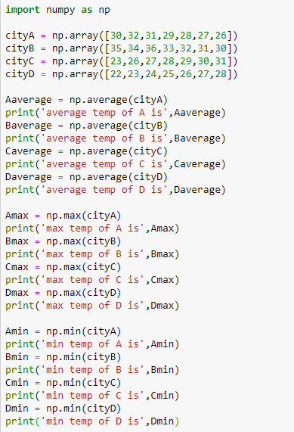

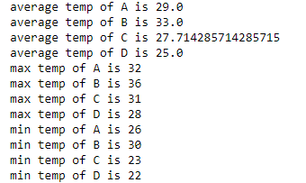

Code:

import numpy as np

cityA = np.array([30,32,31,29,28,27,26])

cityB = np.array([35,34,36,33,32,31,30])

cityC = np.array([23,26,27,28,29,30,31])

cityD = np.array([22,23,24,25,26,27,28])

Aaverage = np.average(cityA)

print('average temp of A is',Aaverage)

Baverage = np.average(cityB)

print('average temp of B is',Baverage)

Caverage = np.average(cityC)

print('average temp of C is',Caverage)

Daverage = np.average(cityD)

print('average temp of D is',Daverage)

Amax = np.max(cityA)

print('max temp of A is',Amax)

Bmax = np.max(cityB)

print('max temp of B is',Bmax)

Cmax = np.max(cityC)

print('max temp of C is',Cmax)

Dmax = np.max(cityD)

print('max temp of D is',Dmax)

Amin = np.min(cityA)

print('min temp of A is',Amin)

Bmin = np.min(cityB)

print('min temp of B is',Bmin)

Cmin = np.min(cityC)

print('min temp of C is',Cmin)

Dmin = np.min(cityD)

print('min temp of D is',Dmin)

Q2:

Code:

import matplotlib.pyplot as plt

import numpy as np

days = [1,2,3,4,5,6,7]

cityA = [30,32,31,29,28,27,26]

cityB = [35,34,36,33,32,31,30]

cityC = [23,26,27,28,29,30,31]

cityD = [22,23,24,25,26,27,28]

def averageTempOfFirstDayOfEachCity():

average = (cityA[0]+cityB[0]+cityC[0]+cityD[0]) / (4)

print(average)

averageTempOfFirstDayOfEachCity()

Output:

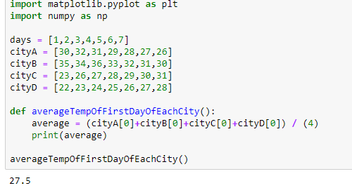

Q3:

Code:

import matplotlib.pyplot as plt

import numpy as np

days = [1,2,3,4,5,6,7]

cityA = [30,32,31,29,28,27,26]

cityB = [35,34,36,33,32,31,30]

cityC = [23,26,27,28,29,30,31]

cityD = [22,23,24,25,26,27,28]

plt.title('Temperature trend of cities over 7 days')

plt.xlabel('Days')

plt.ylabel('Temperature')

plt.plot(days,cityA,color='red')

plt.legend(cityA)

plt.plot(days,cityB,color='green')

plt.legend(cityB)

plt.plot(days,cityC,color='blue')

plt.legend(cityC)

plt.plot(days,cityD,color='black')

plt.legend(cityD)

plt.show()

Output:

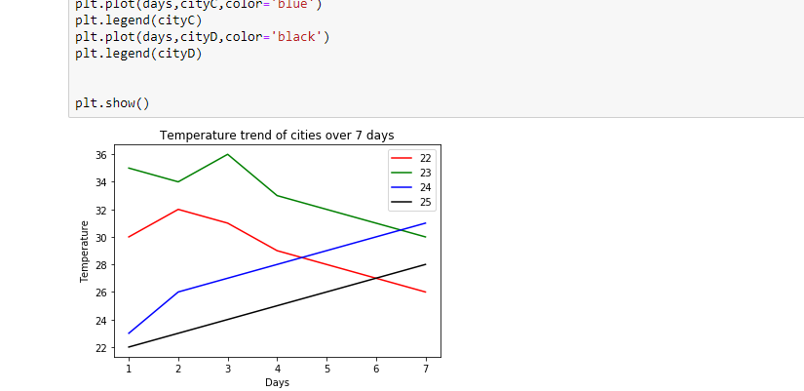

Q4:

Code:

import matplotlib.pyplot as plt

import numpy as np

cityA = [30,32,31,29,28,27,26]

cityB = [35,34,36,33,32,31,30]

cityC = [23,26,27,28,29,30,31]

cityD = [22,23,24,25,26,27,28]

cities = [1,2,3,4]

Arange = np.max([30,32,31,29,28,27,26]) - np.min([30,32,31,29,28,27,26])

Brange = np.max([35,34,36,33,32,31,30]) - np.min([35,34,36,33,32,31,30])

Crange = np.max([23,26,27,28,29,30,31]) - np.min([23,26,27,28,29,30,31])

Drange = np.max([22,23,24,25,26,27,28]) - np.min([22,23,24,25,26,27,28])

plt.bar(cities,Arange,color='red')

plt.bar(cities,Brange,color='green')

plt.bar(cities,Crange,color='blue')

plt.bar(cities,Drange,color='black')

plt.show()

Output:

